 |  | Bath Community School / April Edition
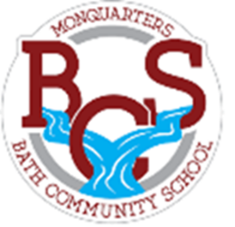
Monquarter Memo
Phone: 278-6000 Twitter: @BathMonquarters
Website: http://BCS.nbed.nb.ca/
Upcoming:
Friday, April 9th  Grade 7 & 8 trip to Sugar Moon  Tuesday, April 13th  *Parent teacher evening  Wednesday, April 14th  No school for students  *Parent teacher morning and professional learning afternoon for staff.  *Teachers are scheduling phone calls  or video conferences to conduct  parent teacher interviews.*  April is National Poetry Month!  BCS is hosting a poetry contest for our young writers. Here’s how to enter:  - Create an original poem with a Spring theme.  - Submit your best work to your teacher by April 28th.  - Make sure your full name is on your poem!  - Winners will be chosen by grade level groups (K-2, 3-5 and 6-8).  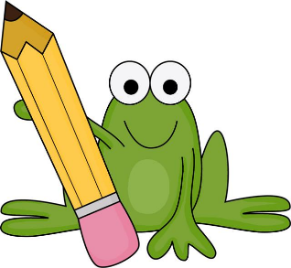  - The winning poems will be featured in next month’s Monquarter Memo.  CHARACTER STRONG |  |  | 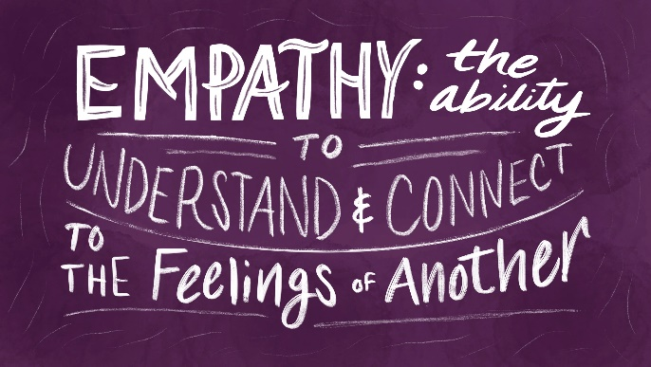 |  | - PLEASE send your student with a water bottle each day.  We only have water bottle filling stations, no fountains!  Thursday, April 22nd  is EARTH DAY!  How can you help at home?  Here is some inspiration!  - Eat local: Eat fresher products  and reduce greenhouse gas emissions from transport.  - Lower your thermostat: Did you know that 19°C is the “thermoneutrality” temperature of the human species? No need to heat above that, especially when you know that, above 20°C, each additional degree increases the heating bill by 7%. So, save your wallet and the environment!  - Opt for second-hand purchases: Thrift stores, second-hand shops, garage sales… There are plenty of opportunities to buy second-hand. You can also organize exchanges with family/friends/neighbours!  - Grow your own vegetable garden: Whether you have space for a large garden or a container garden, it is time to start growing your own vegetables and herbs.  #EARTHDAYATHOME
 |  |  |  |  | 